PYTHON PROGRAMMING:
IMPORTANT KEY POINT:
- Every programs have grammatical rules.
- Language of computer is java, python, c++.
- Calculated problem become easier.

Data is binary code in pc.
- The data store as in the variable i.e temporary storage base.
- Variable has data and name and address where it store in memory.
- We perform multiple operation in variable such as +-,-,*,%,/.

IF-ELSE:
- We also do decision by using variables and statement and condition.
- Main parts are if, else and ifelse.
e.g
print("hello what is your name?");
x=input();
if x=='seher':
print(x);

else:
print("name is not seher");
ELIF:
print("hello what is your name?");
x=input();
if x=='seher':
print(x);

elif:
print("name is not seher");

LOOP:
- Loop statement are used to repeat task.
While Loop:
# while loop
i = 0
while i < len(value):
print(x)
if i == len(value) - 1:
break
i += 1
For Loop:
# use of range() to defin
e a range of values
values = range(4)

# iterate from i = 0 to i = 3
for i in values:
print(i)

Do while loop:
while True:
# code to be executed

# check if the condition is met to exit the loop
if condition:
break
FOR-ELSE:
digits = [0, 1, 5]

for i in digits:
print(i)
else:
print("No items left.")

FUNCTION:
- It is a block of code which perform specific task.

OOP CONCEPT:
- CLASSES:
Template/blue print for real world entities.
- OBJECTS:
Specific instances of class.

ALGORITMS:
It’s step by step approach to solve a programming question.
PYTHON INTRO:
FREE OPEN SOURCE PROGRAMMING LANGUAGE OPEN SOURCE.it is a standard library. Have oop concept. Cross platform compatible.

DOWNLOAD:
Download pycharm, anaconda for data science practitioners and data visualization and Jupyter notebook.
SIMPLE INPUT:
print("hello what is your name?");
x=input();
print(x);
JUPYTER INTRO:
Browser-based interpreter that allow us to interactively work with python.in this kernel is the executer of the program. We work by adding cell.
VARIABLE AND DATA TYPES:
INITIALIZING VARIABLE:
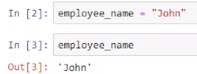
We can change variable name.
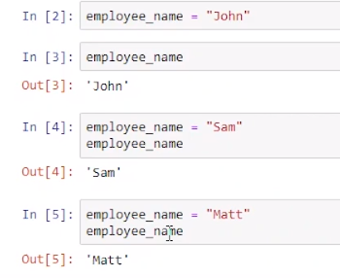
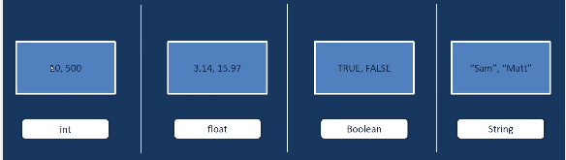
DATATYPES:
To check data type
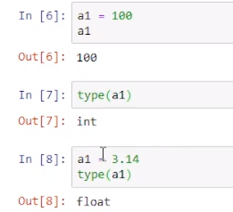
Complex number in python:
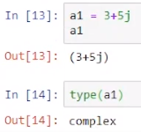
OPERATOR:
- ARITHEMATIC OPERATOR:
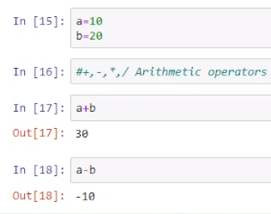
- RELATIONAL OPERATOR:
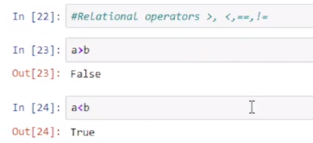

- LOGICAL OPERATOR:
AND: both condition should true.
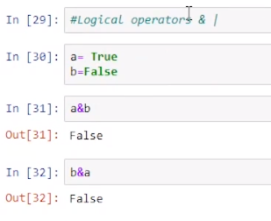
OR: even single true value give true.

TOKENS:
Smallest meaningful component in a program.
- KEYWORDS:
Special reserve words. These are unique words.
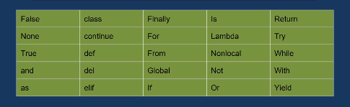
- IDENTIFIERS:
Use for variables, functions and objects.
RULES:
No special character except (_).
They are case sensitive.
First letter cannot be digit.
Ex.
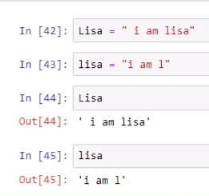
- LITERALS:
Literals are constant. They cannot be damage.
- OPERATORS:
Already study.
STRINGS:
Sequence of character.
Ex.
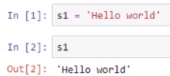
MULTILINE STRING:
EX.
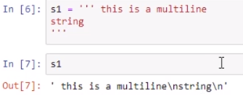
EXTRACTING SINGLE CHARATER:
Indexing start with 0.
EX.
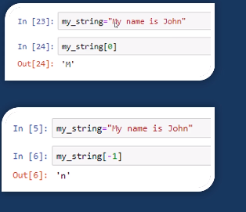
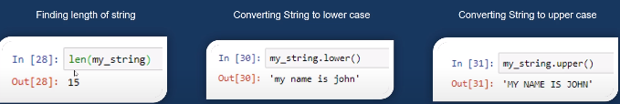
SOME SPECIAL CASE:

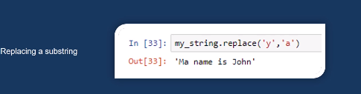
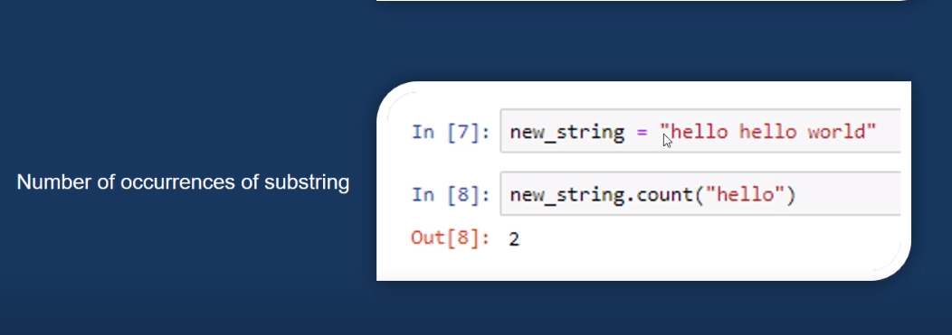
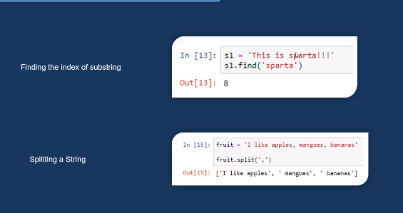

DATA-STRUCTURE IN PYTHON:
- Tuple.
- List.
- Dictionary.
- Set.

- TUPLE:
It is an order collection of element enclosed in (0).once we create it we can not change it that is why it is called immutable. Similar to structures.
Ex.
Tup1={1,’a’,True}
*CANCATINATION OF TUPLE:
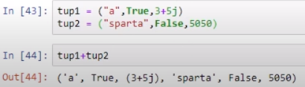
Sequence matter.

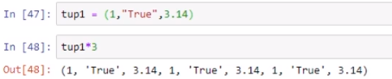
*REPETING TUPLE ELEMENT:
*MINIMUM VALUE AND MAXIMUM VALUE:
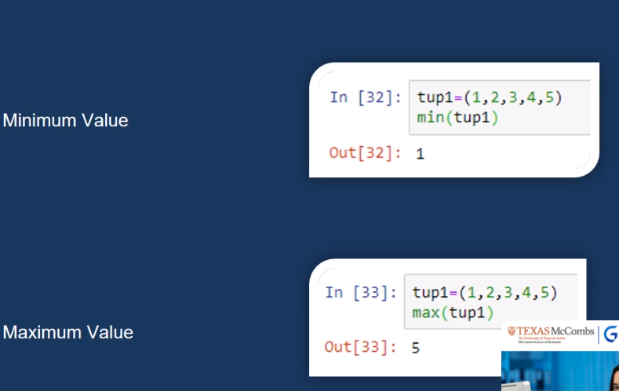
2) LIST:
List is an ordered collection of element enclosed in [].
List are mutable.
Ex.
L1= [1, 2, 2.3, ’a’, 3+3j]
REMAIN THINGS ARE SAME.
SOME SPECIAL FUNCTIONS:

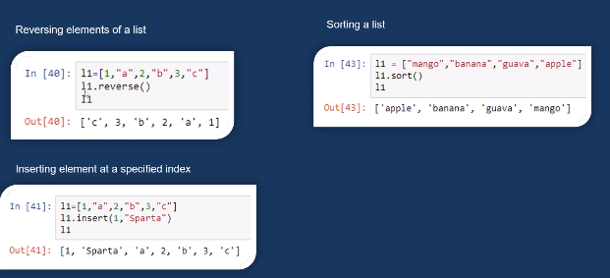
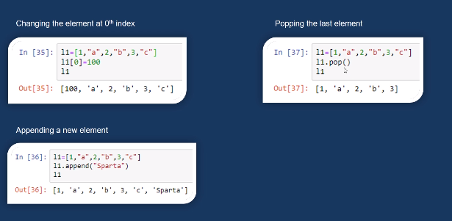

- DICTIONARY:
Dictionary is an unordered collection of key-value pairs enclosed with {}. It is mutable.
Ex. Fruit= {“APPLE”:10, “ORANGE”:20}
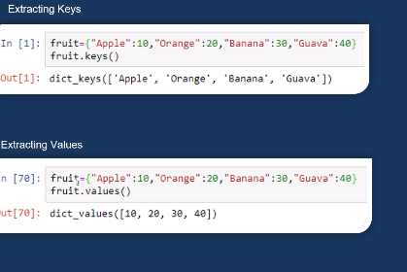
*EXTRACTING KEY AND VALUES:
And if you want both key and value at the same time write.
Dictionary name.item()
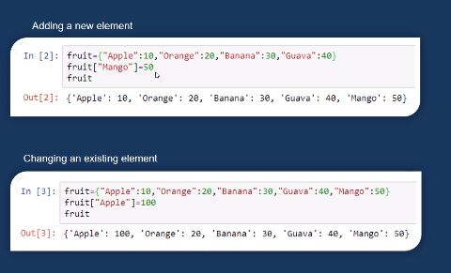
*MODIFICATION:
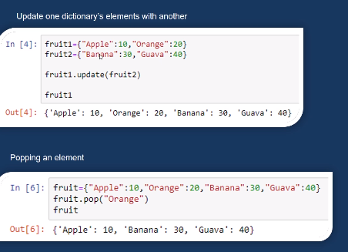

- SET:
UNINDEX COLLECTION OF ELEMNT ENCLOSED IN{}.
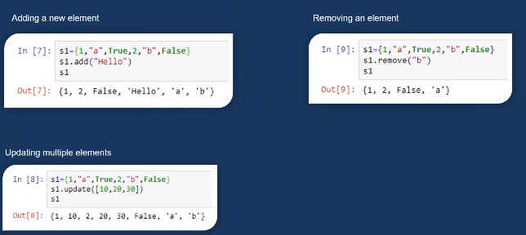
*modification:
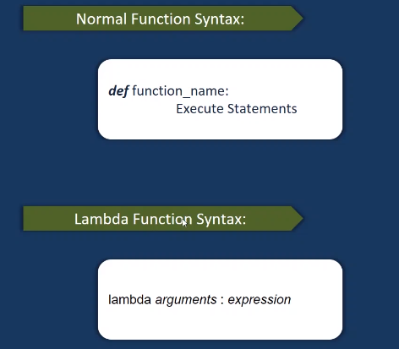
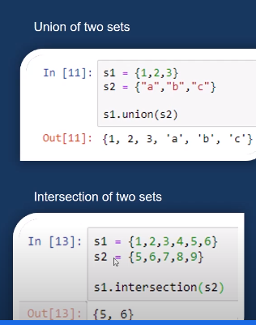
FUNCTIONS :
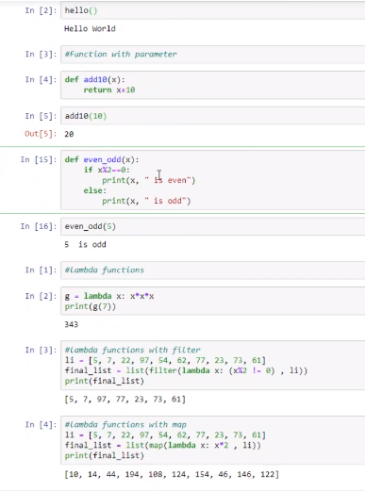
EXAMPLE:

TYPE CASTING:
Str()=any data type into string
Int()=any data type into integer
Float()=any data type into float
Ord(),hex(),oct(),tuple(),set(),dic()

